
GURUKUL

Grow with Gurukul

Top Courses in machine learning, Deep Learning and Data Science for free.

If you are curious enough to learn by your own.
Here is something for you to learn and deploy your skills.

Sadashiv

Courses with certificates
Amazon AWS

https://www.aws.training/Dashboard

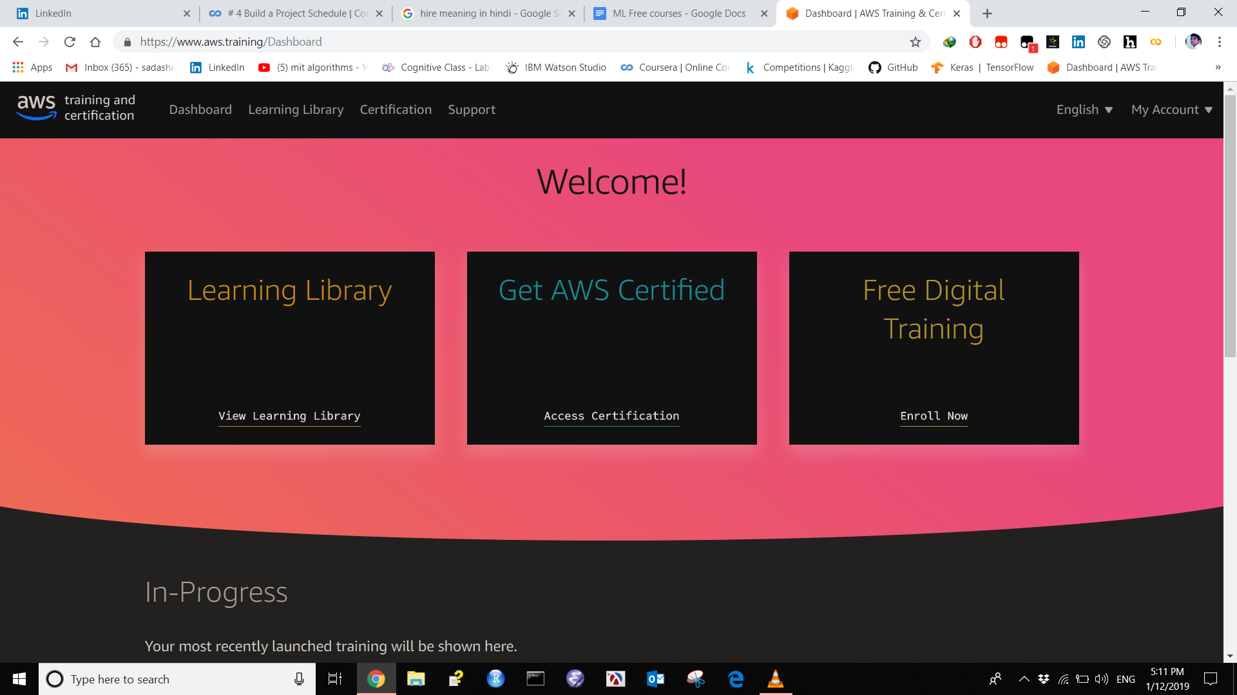

IBM Watson studio

Cognitive class

https://cognitiveclass.ai/

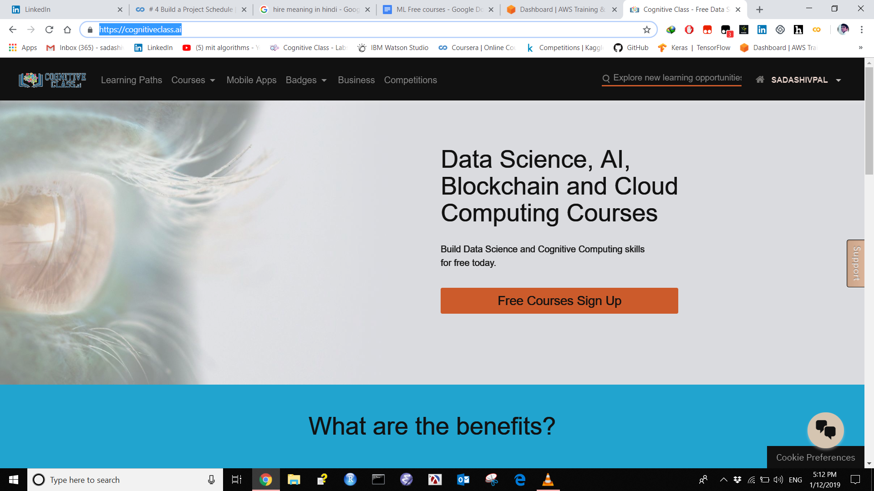

Courses without certificates
1 Machine Learning
University of Washington
This course is designed to provide a thorough grounding in the fundamental methodologies and algorithms of machine learning. The topics of the course draw from classical statistics, from machine learning, from data mining, from Bayesian statistics, and from optimization.
Prerequisites: Students entering the class should be comfortable with programming and should have a pre-existing working knowledge of linear algebra, probability, statistics and algorithms.

https://courses.cs.washington.edu/courses/cse546/17au/

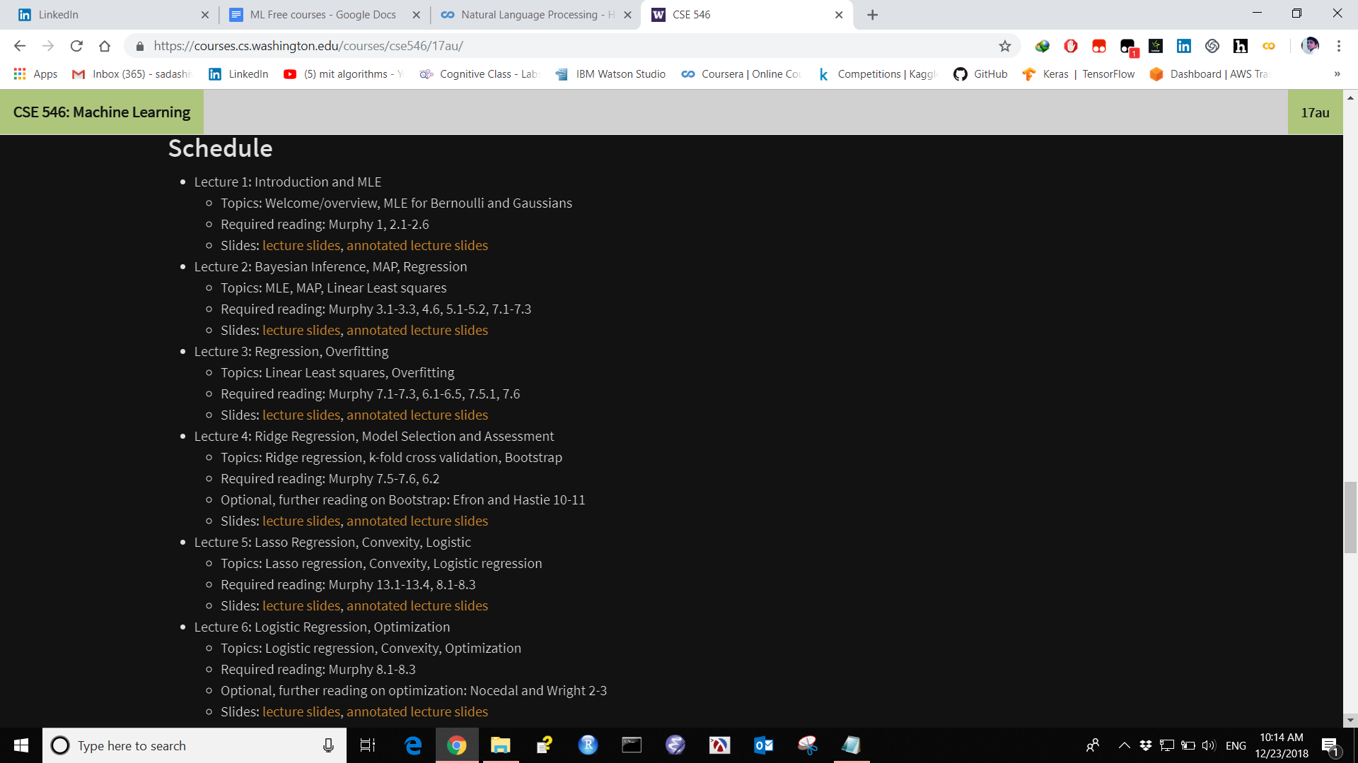

200 Best Resources

https://medium.com/machine-learning-in-practice/over-200-of-the-best-machine-learning-nlp-and-python-tutorials-2018-edition-dd8cf53cb

2. Machine Learning

University of Wisconsin–Madison
This course will cover the key concepts of machine learning, including classification, regression analysis, clustering, and dimensionality reduction. Students will learn about the fundamental mathematical concepts underlying machine learning algorithms, but this course will equally focus on the practical use of machine learning algorithms using open source libraries from the Python programming ecosystem.
http://pages.stat.wisc.edu/~sraschka/teaching/stat479-fs2018/
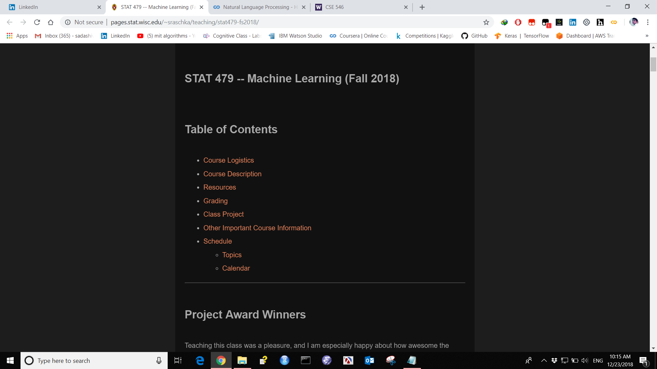

3. Algorithms (in Journalism)
Columbia University
This is a course on algorithmic data analysis in journalism, and also the journalistic analysis of algorithms used in society. The major topics are text processing, visualization of high dimensional data, regression, machine learning, algorithmic bias and accountability, monte carlo simulation, and election prediction.
All coding is done in Python, using Pandas, matplotlib, scikit learn.
https://github.com/jstray/lede-algorithms/blob/master/README.md
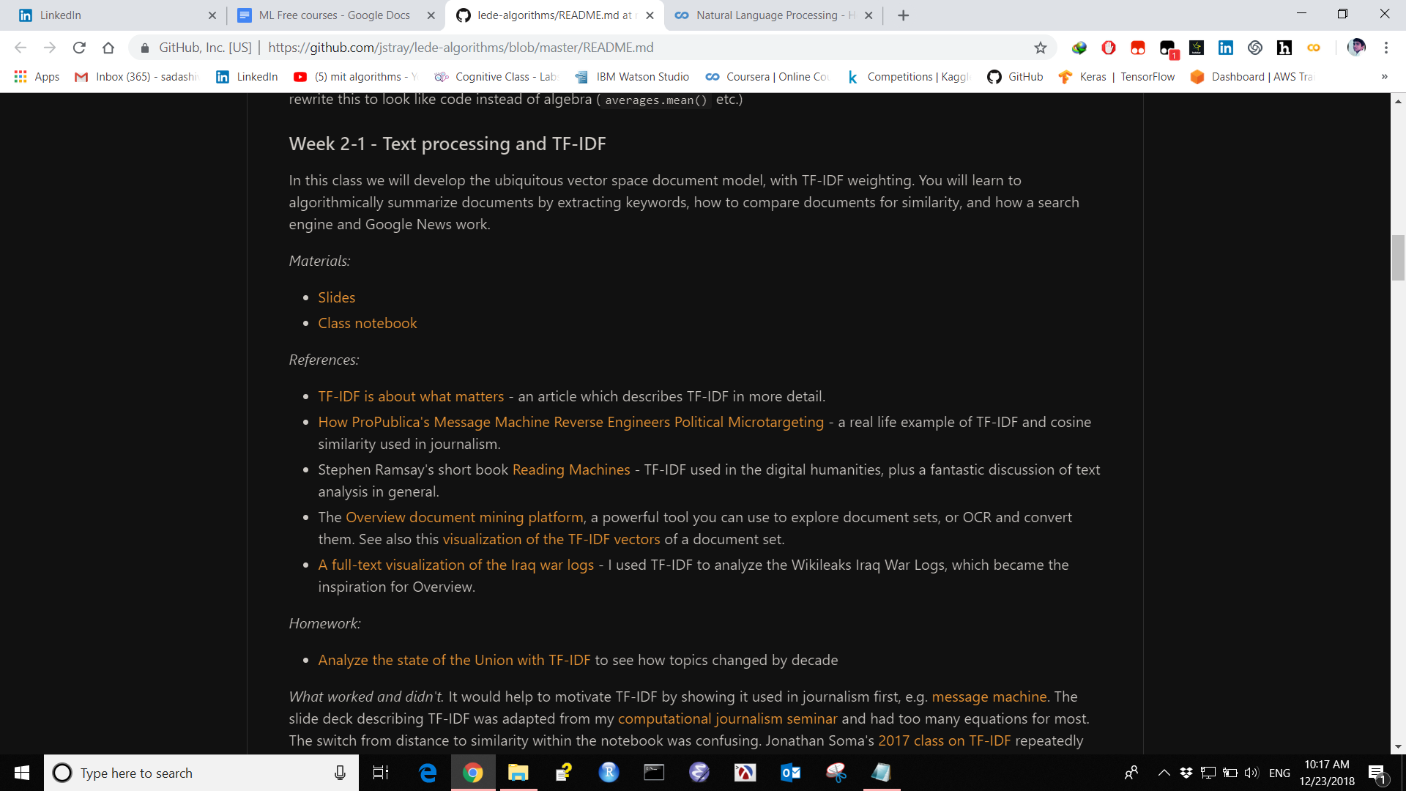

4. Practical Deep Learning

Yandex Data School

https://github.com/yandexdataschool/Practical_DL/tree/master

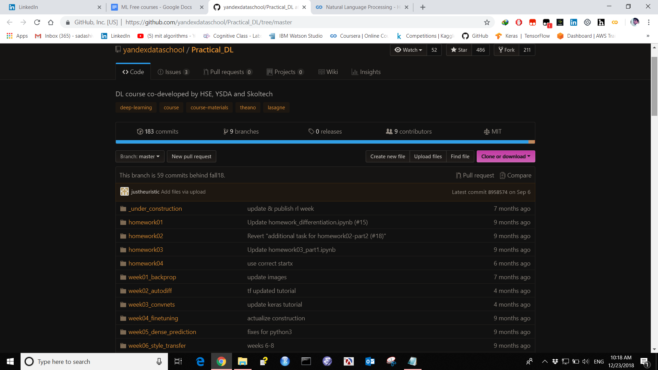

5. Big Data in 30 Hours
Krakow Technical University
The goal of this technical, hands-on class is to introduce practical Data Engineering and Data Science to technical personnel (corporate, academic or students), during 15 lectures (2 hours each). All subjects are introduced by examples that students are expected to immediately play with using either command-line or GUI tools.
Prerequisites: the participants need to be technical, reasonably fluent in general programming and operating systems, with basic exposure to Linux shell, databases, and SQL. Working knowledge of Python will be needed for the lectures 9-15.
Note that this course is underdevelopment, and not all lessons have been completed.
http://ondata.blog/big-data-in-30-hours/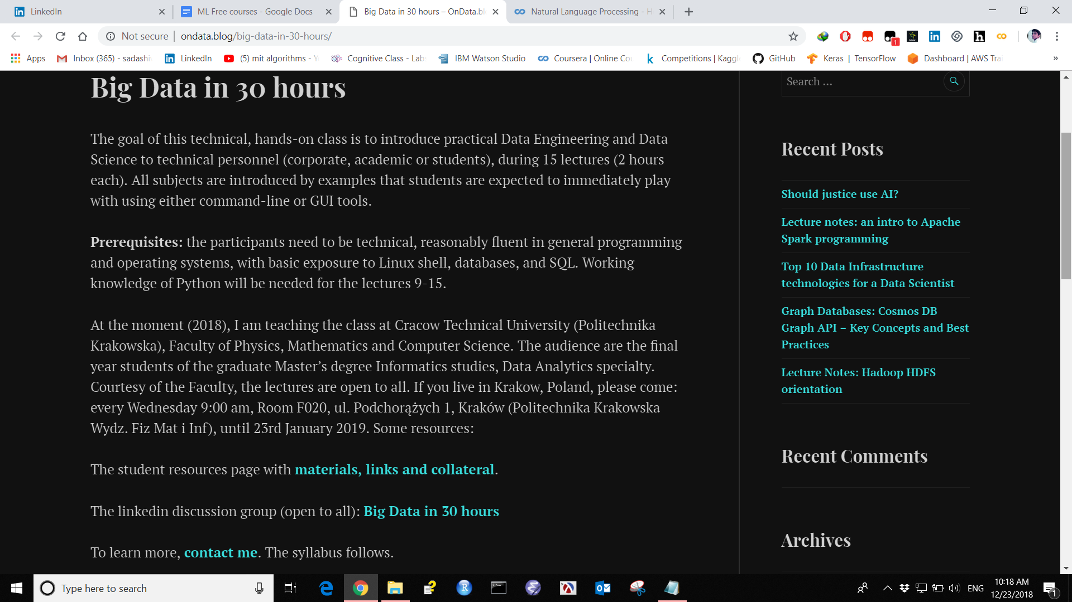

6. Deep Reinforcement Learning Bootcamp
UC Berkeley (& others)
Reinforcement learning considers the problem of learning to act and is poised to power next generation AI systems, which will need to go beyond input-output pattern recognition (as has sufficed for speech, vision, machine translation) but will have to generate intelligent behavior. Example application domains include robotics, marketing, dialogue, HVAC, optimizing healthcare and supply chains.
​This two-day long bootcamp will teach you the foundations of Deep RL through a mixture of lectures and hands-on lab sessions, so you can go on and build new fascinating applications using these techniques and maybe even push the algorithmic frontier.
https://sites.google.com/view/deep-rl-bootcamp/lectures
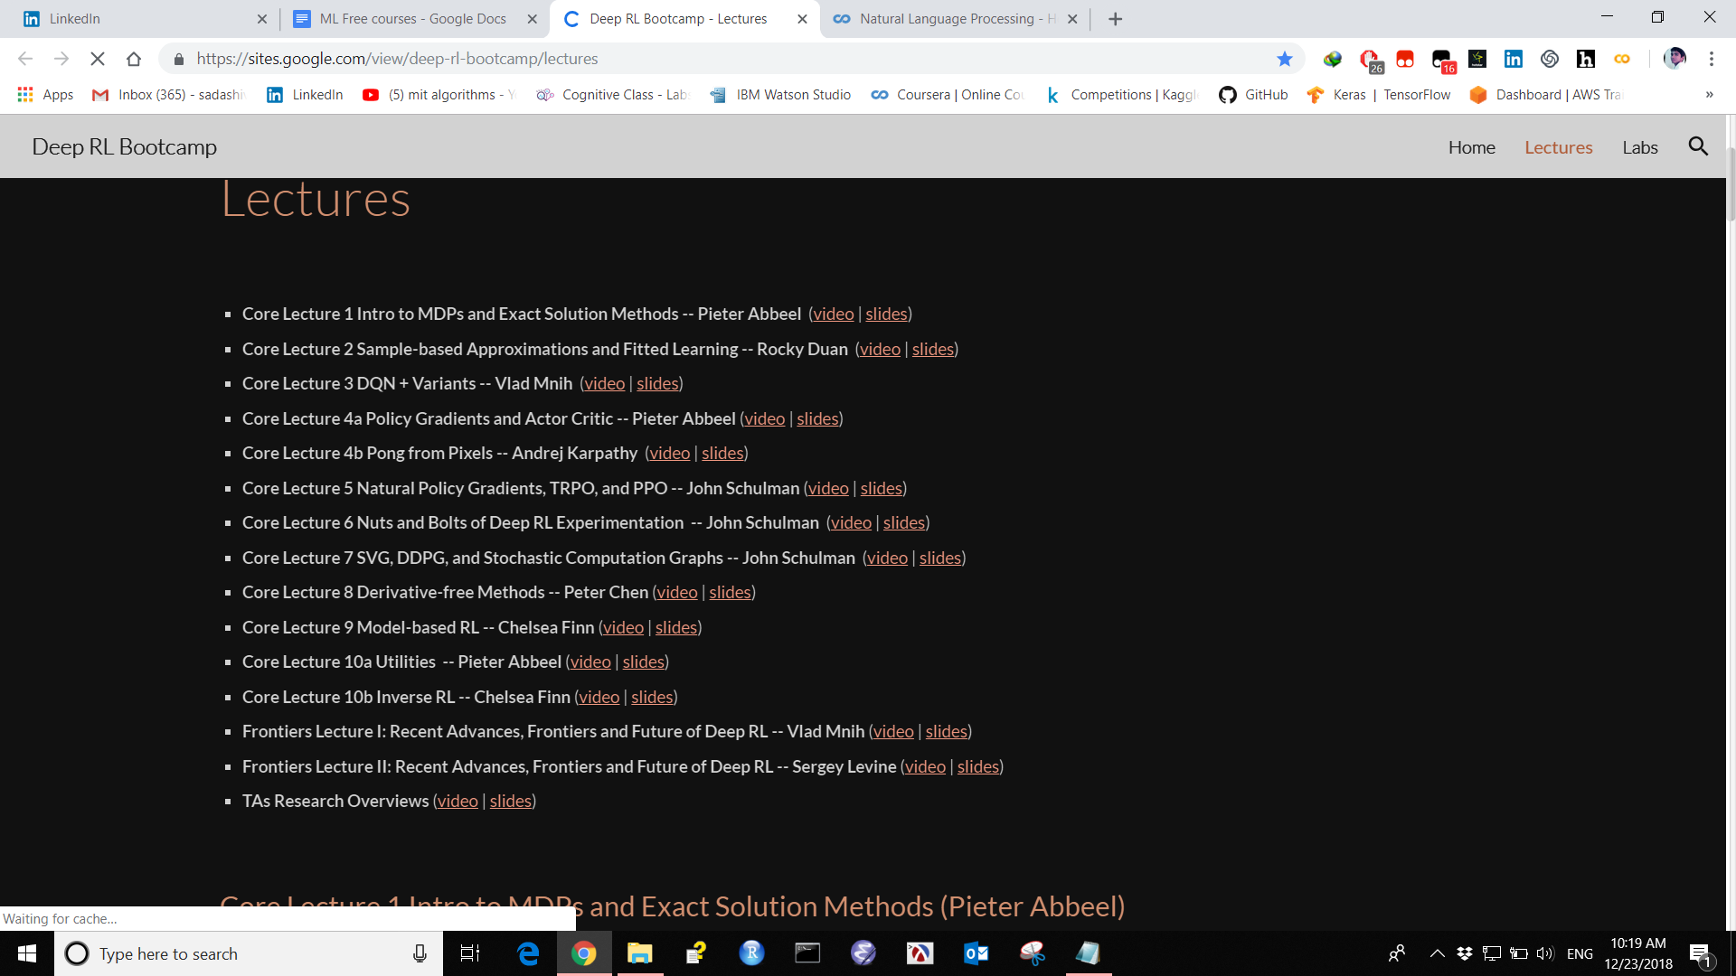

7. Introduction to Artificial Intelligence

University of Washington

Course contain Lectures, Slides.

https://courses.cs.washington.edu/courses/cse573/17wi/

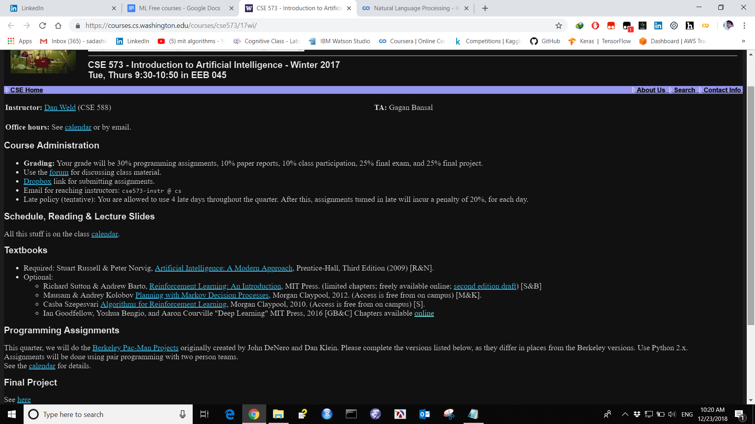

8. Brains, Minds and Machines Summer Course
MIT
This course explores the problem of intelligence—its nature, how it is produced by the brain and how it could be replicated in machines—using an approach that integrates cognitive science, which studies the mind; neuroscience, which studies the brain; and computer science and artificial intelligence, which study the computations needed to develop intelligent machines. Materials are drawn from the Brains, Minds and Machines Summer Course offered annually at the Marine Biological Laboratory
https://ocw.mit.edu/resources/res-9-003-brains-minds-and-machines-summer-course-su
mmer-2015/

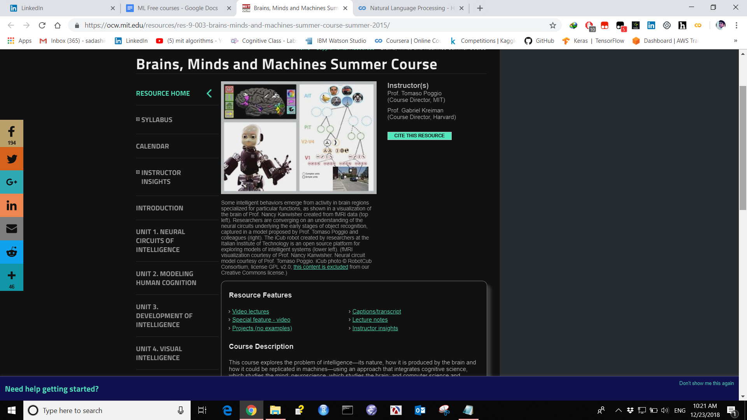

9. Design and Analysis of Algorithms
MIT
This is an intermediate algorithms course with an emphasis on teaching techniques for the design and analysis of efficient algorithms, emphasizing methods of application. Topics include divide-and-conquer, randomization, dynamic programming, greedy algorithms, incremental improvement, complexity, and cryptography.
https://ocw.mit.edu/courses/electrical-engineering-and-computer-science/6-046j-design-and-analysis-of-algorithms-spring-2015/

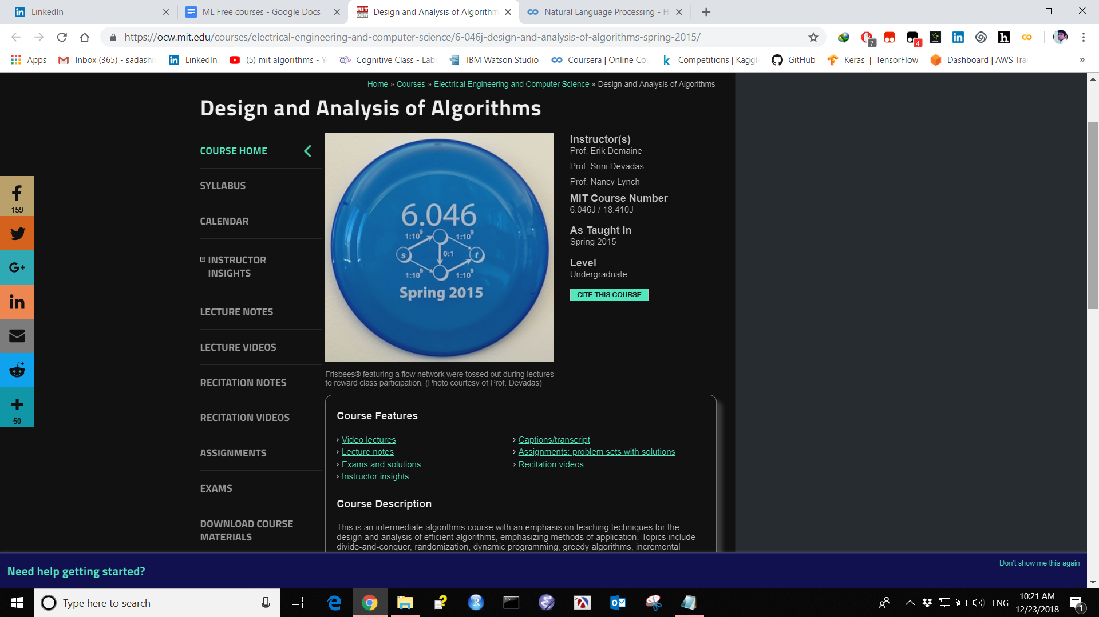

10. Natural Language Processing

University of Washington RNN LSTM GRU

https://courses.cs.washington.edu/courses/cse517/17wi/

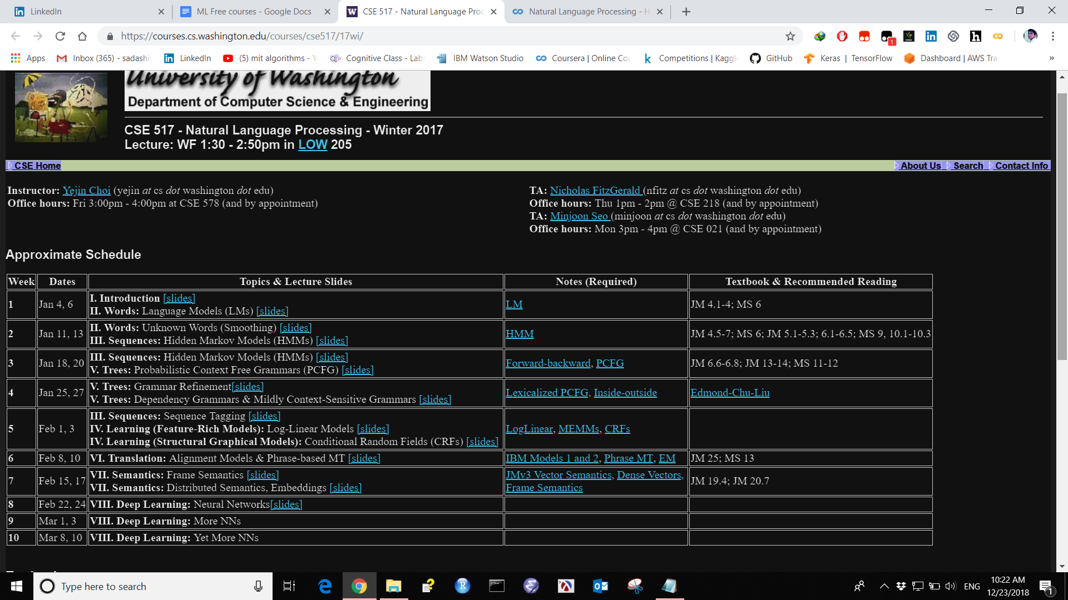

11 Useful Jupyter Notebook for coding

http://nbviewer.jupyter.org/github/roamanalytics/roamresearch/blob/master/BlogPosts/Modern_TensorFlow/modern-tensorflow.ipynb

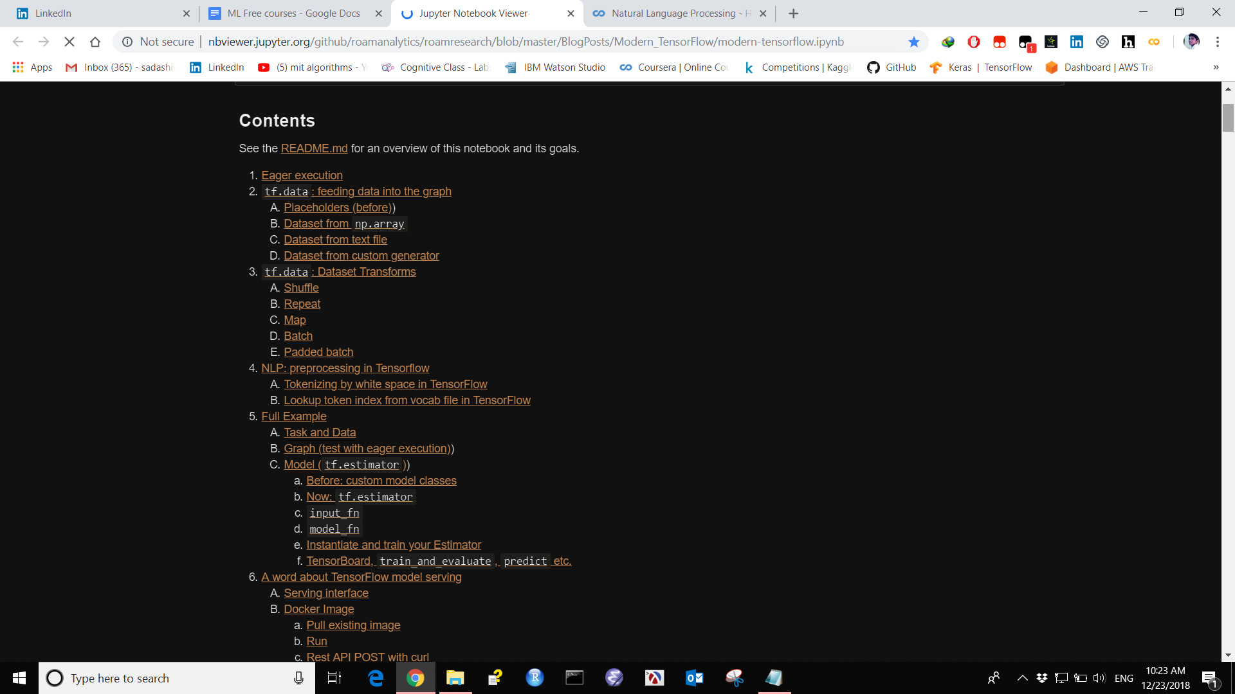

12 AI Saturday learning plan ML DL AI

https://docs.google.com/document/d/1yLjTcuaQSE10uDUDKrvfQO2-FlAdWv8ZC5zH0SyBHY8/edit

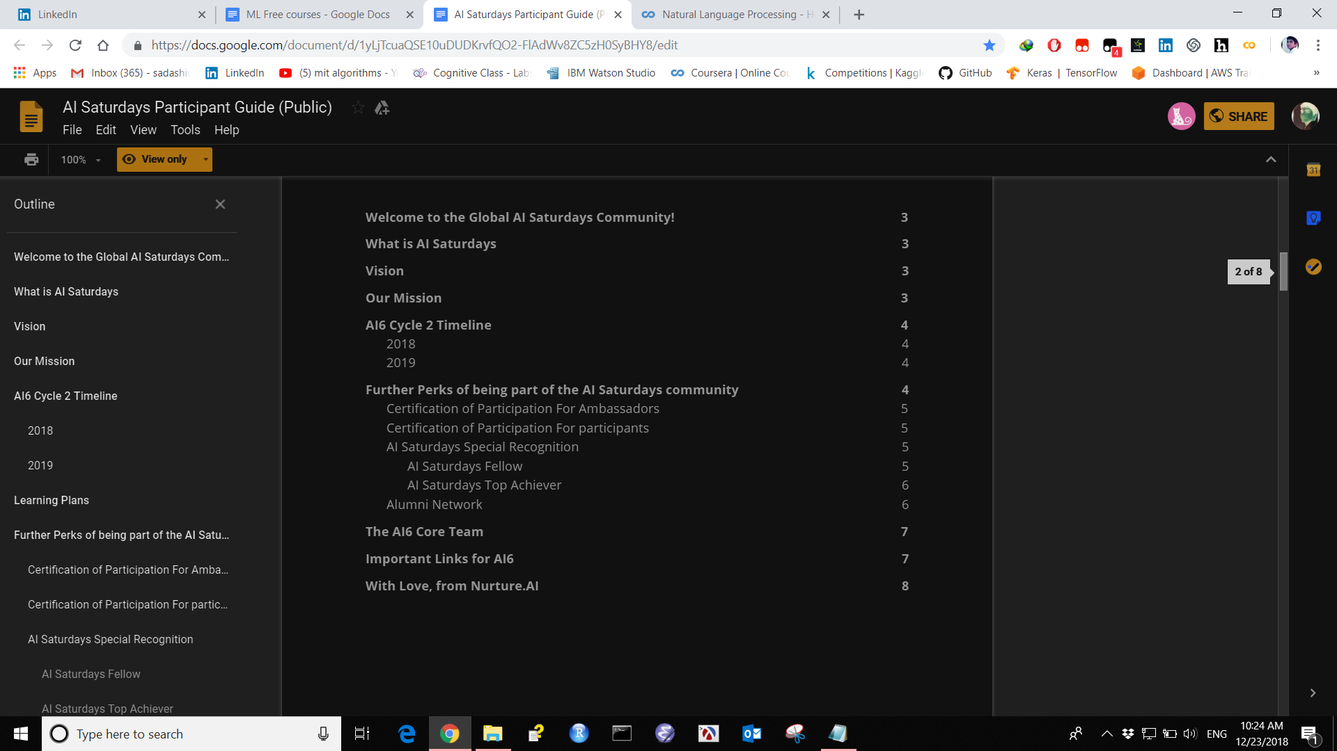

13 Convolutional Neural Network for artistic style transfer

https://harishnarayanan.org/writing/artistic-style-transfer/
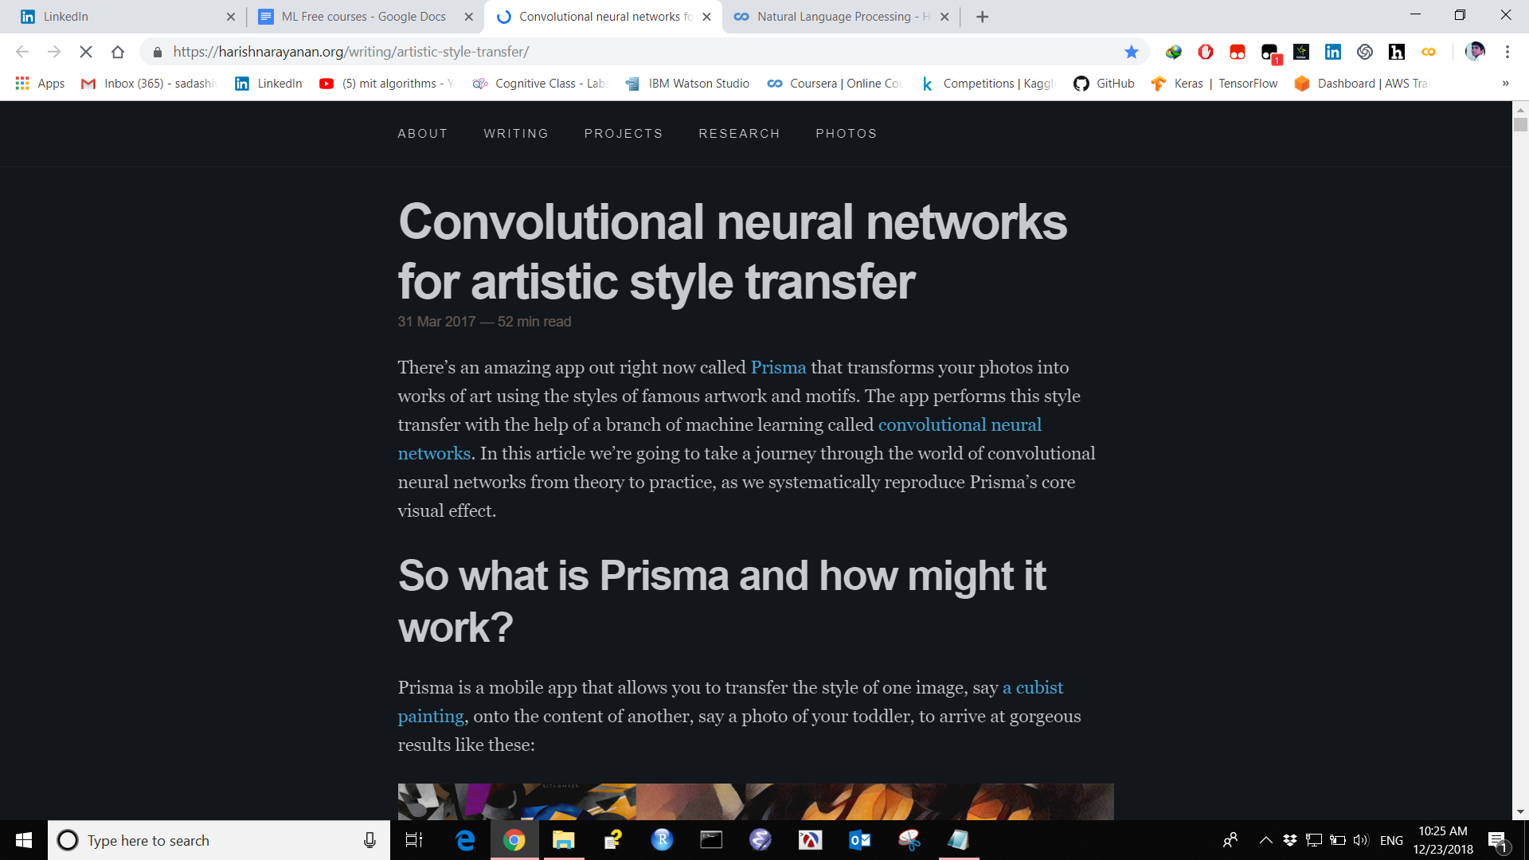

14 Deep Learning course: lecture slides and lab notebooks

https://m2dsupsdlclass.github.io/lectures-labs/

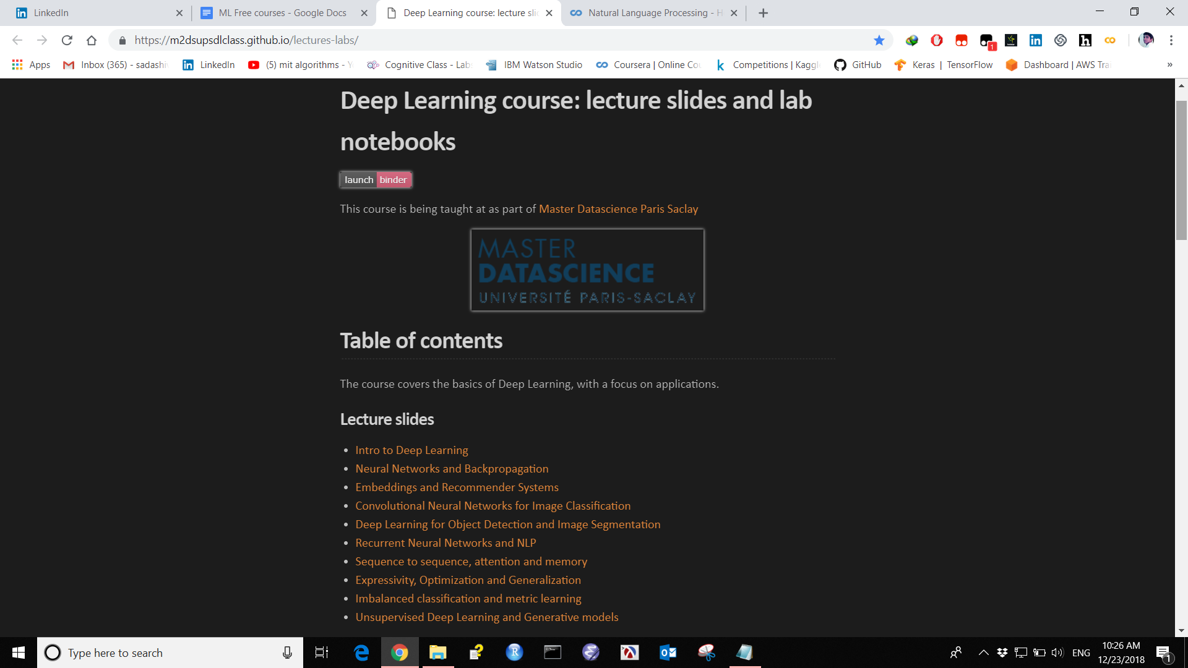

15 Deep RL BOOTCAMP

Contains Lectures slides books.
https://sites.google.com/view/deep-rl-bootcamp/lectures

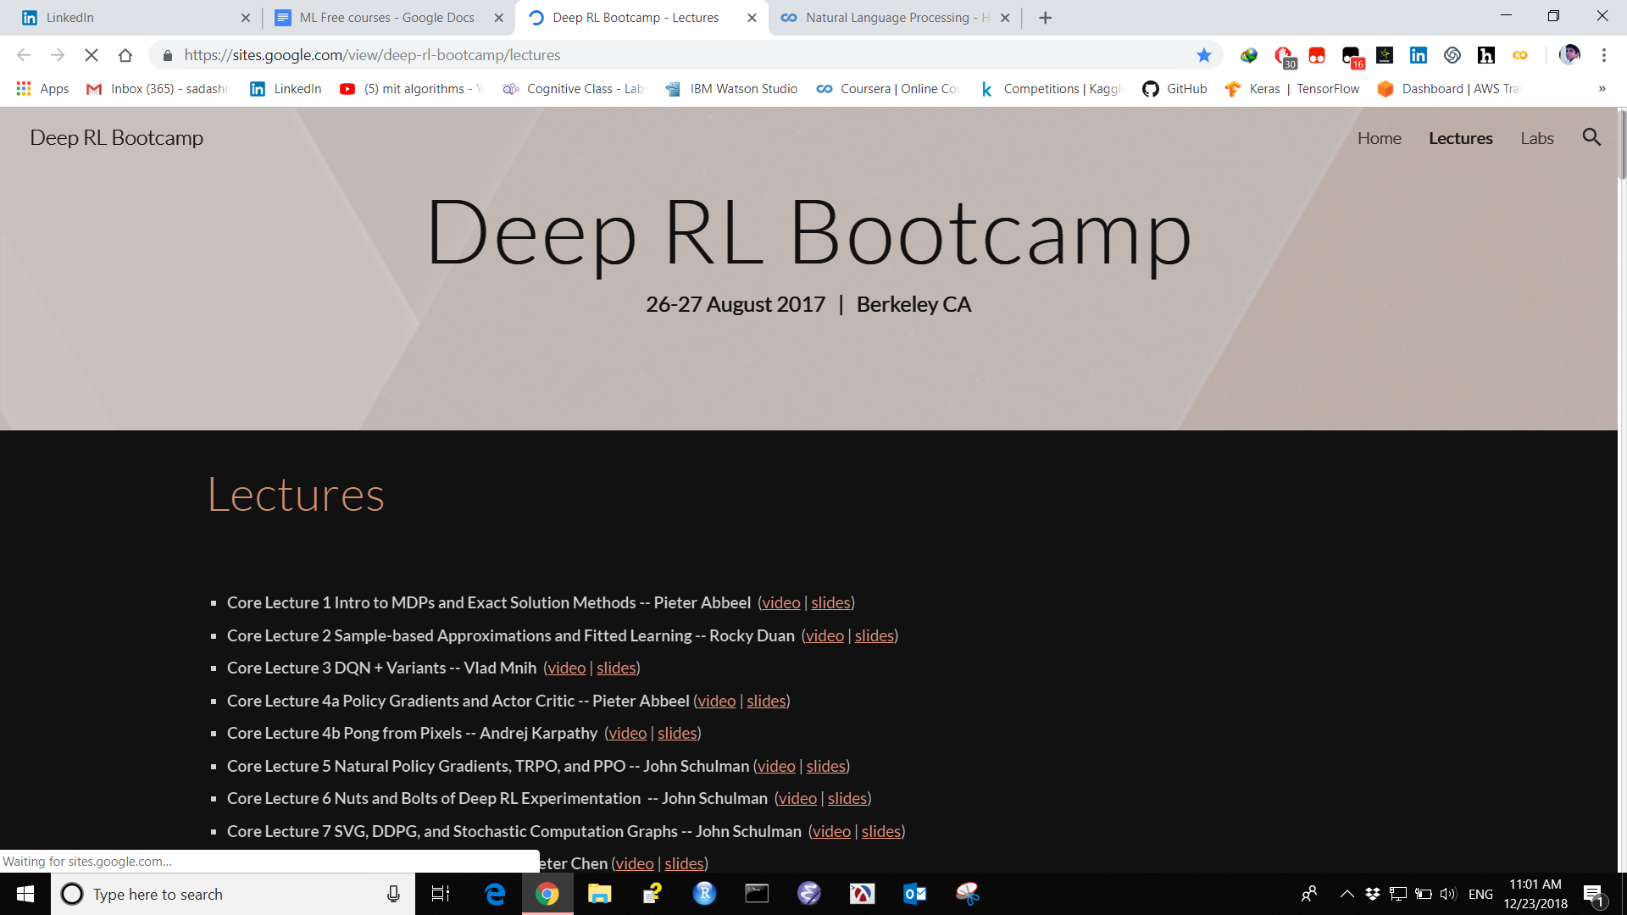

16 monteral.ai

Contain ML AI Lectures Slides Books

https://montrealartificialintelligence.com/academy/
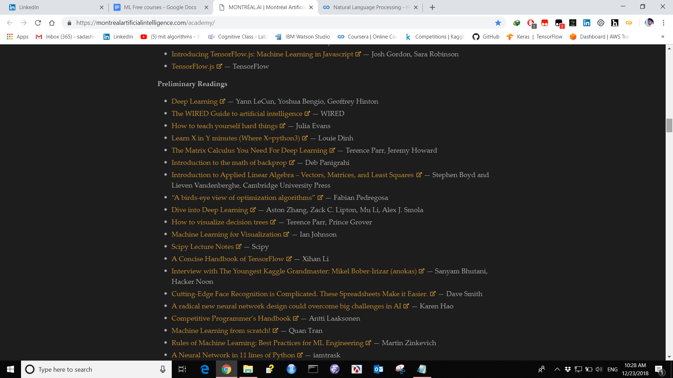

17 From GAN to WGAN

https://lilianweng.github.io/lil-log/2017/08/20/from-GAN-to-WGAN.html#generative-adversarial-network-gan
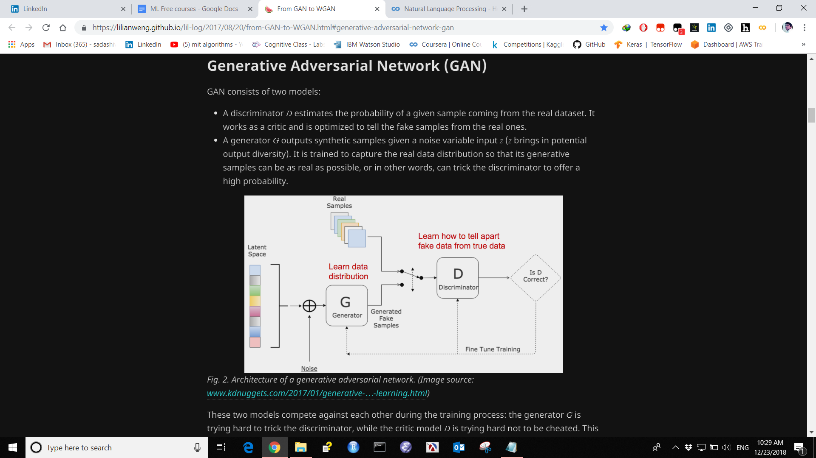

18 Google cloud ML Courses Github repository

Contain Google cloud repository code from Google cloud training course.

https://github.com/GoogleCloudPlatform/training-data-analyst

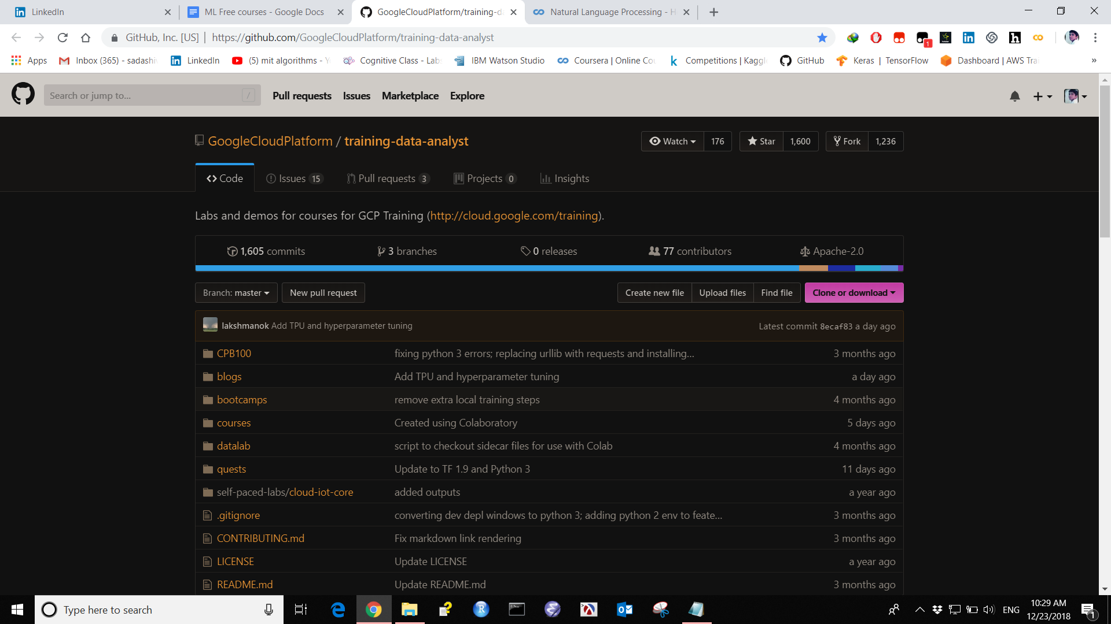

19 Deep learning Machine learning Papers with code

Contain Papers of ML DL with code.

https://paperswithcode.com/
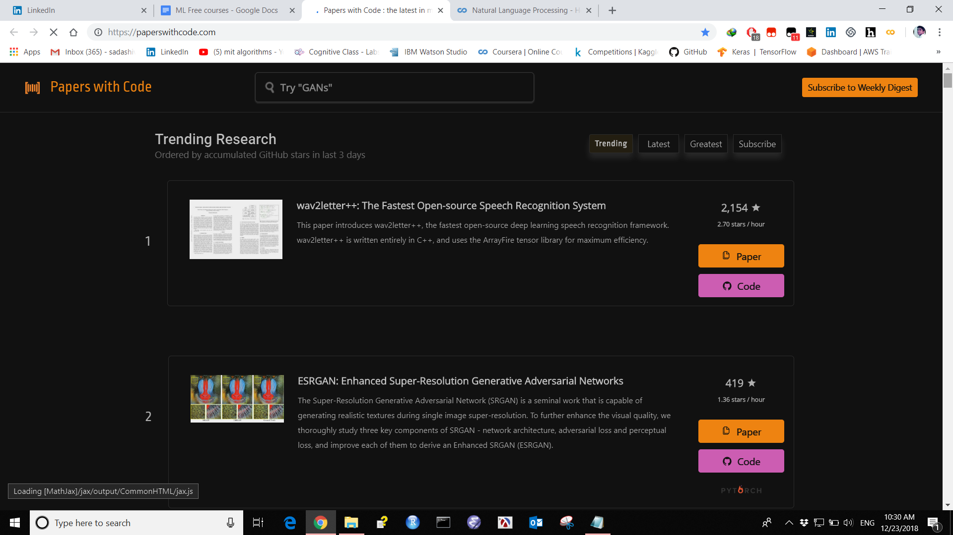

20 Cognitive class By IBM for data science Machine learning

Contain spark Scala Data science track path ML track path Hands on Chatbot.

https://cognitiveclass.ai/
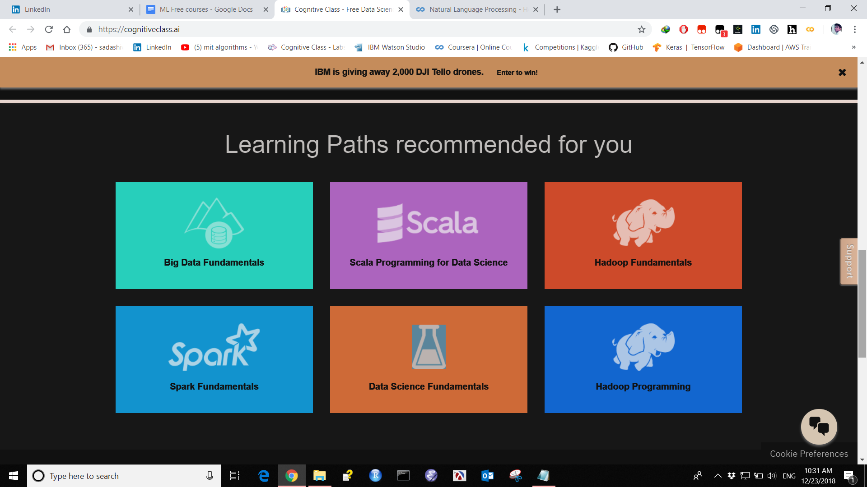

21 AWS Training BY Amazon to learn ML AI Data Science with certificate

AWS training with certificates for free make your career in AWS Cloud course contain ML DL AI DS.

https://www.aws.training/Dashboard

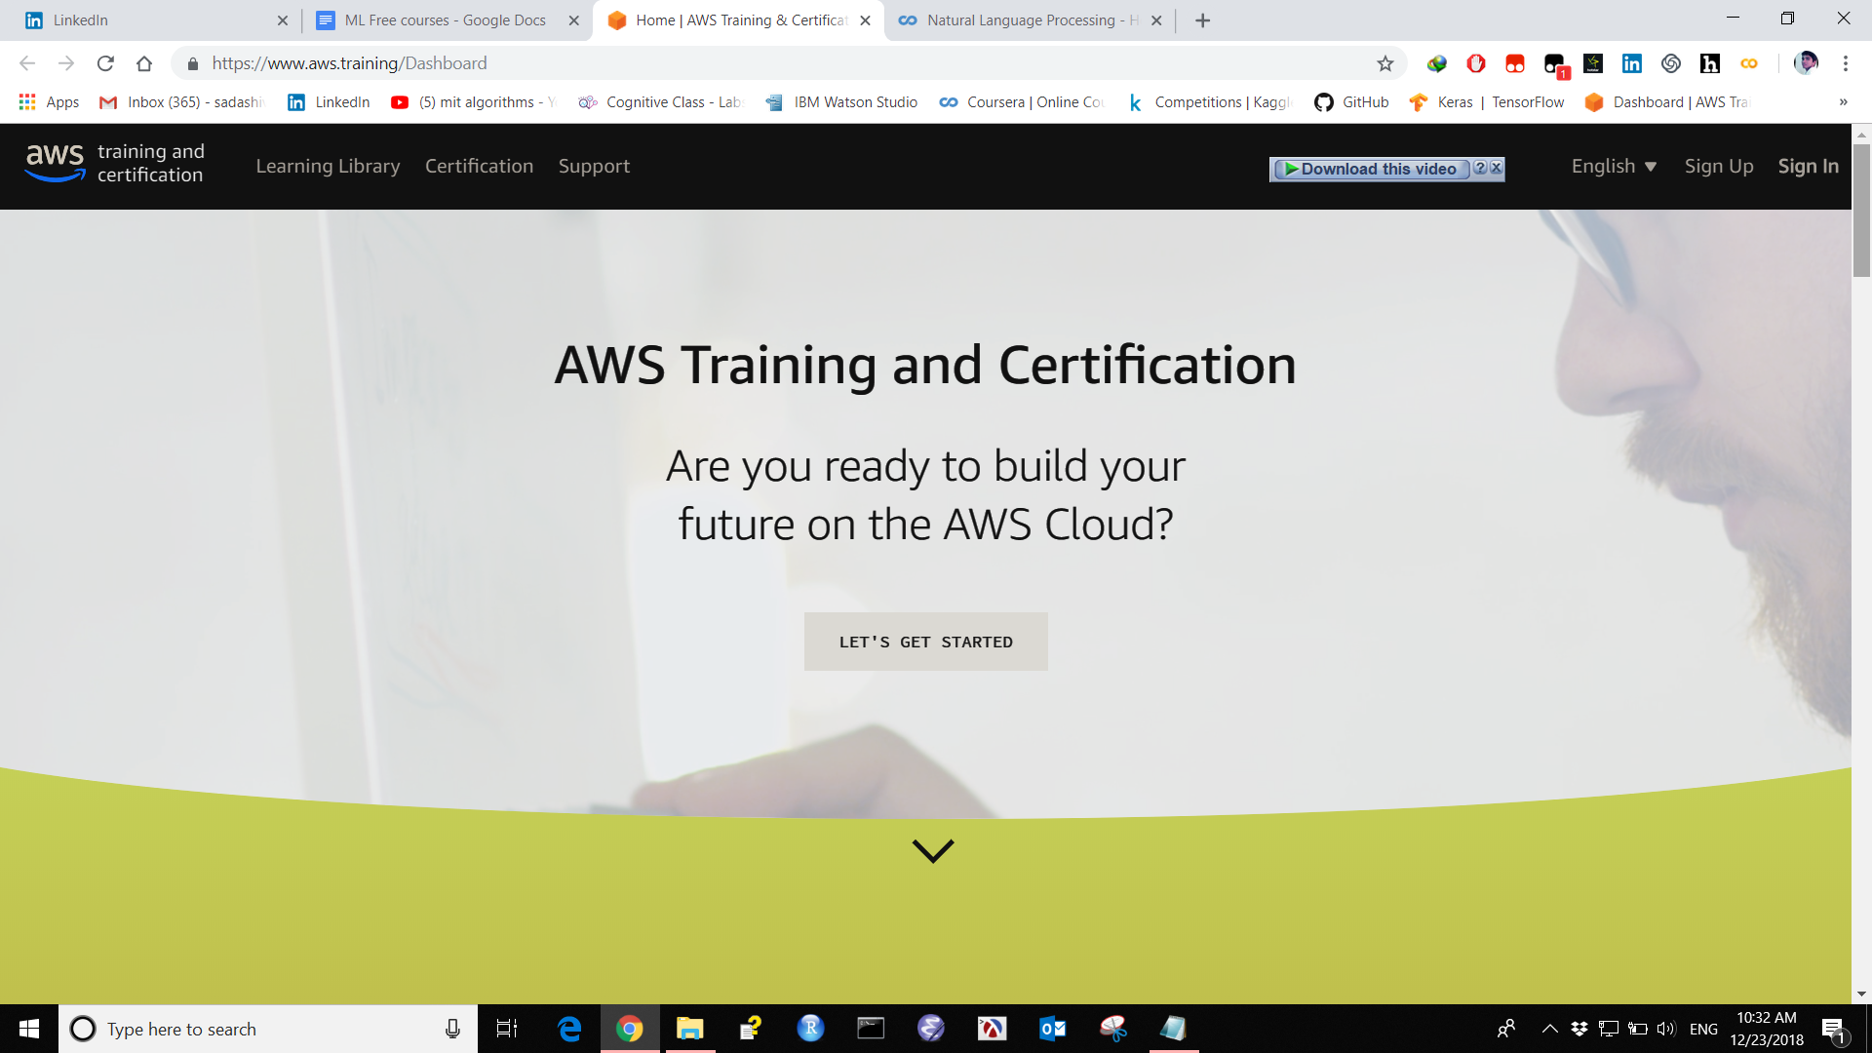

22 Google colab to learn with practice on Cloud

Contain Google colab on cloud

https://colab.research.google.com/notebooks/welcome.ipynb#scrollTo=-Rh3-Vt9Nev9

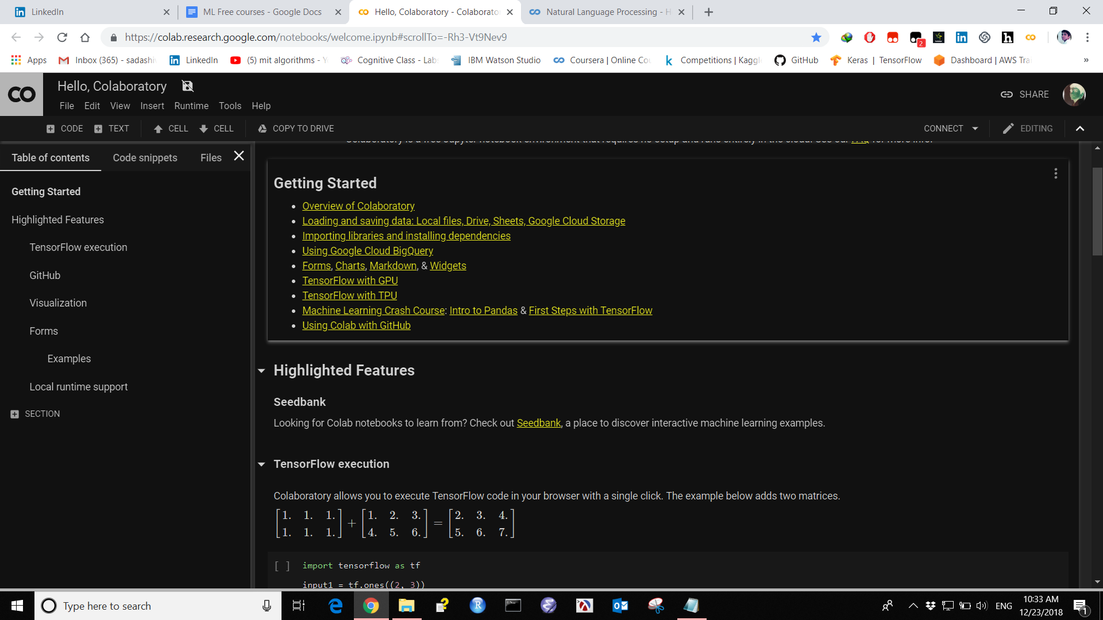

23 NLP Notebook

A Useful Book - Natural Language processing contains Code and Algorithm.

https://docs.google.com/presentation/d/17NoJY2SnC2UMbVegaRCWA7Oca7UCZ3vHnMqBV4SUayc/edit#slide=id.p

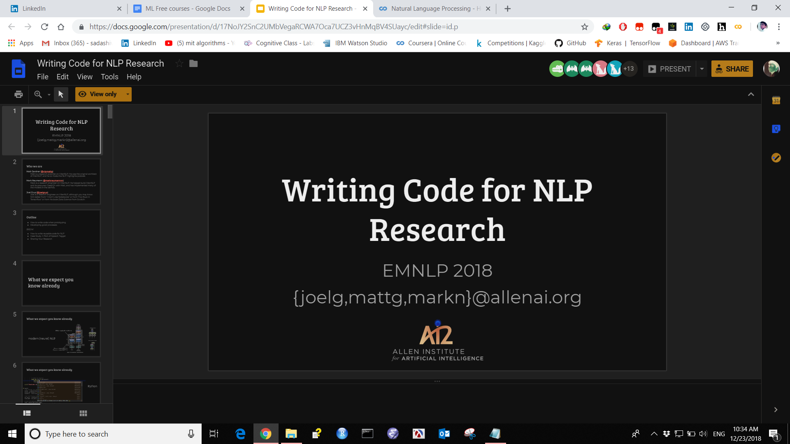

24 A Gallery of Interesting Notebook

Contains Interesting Code in python for ML DL.

https://github.com/jupyter/jupyter/wiki/A-gallery-of-interesting-Jupyter-Notebooks#c

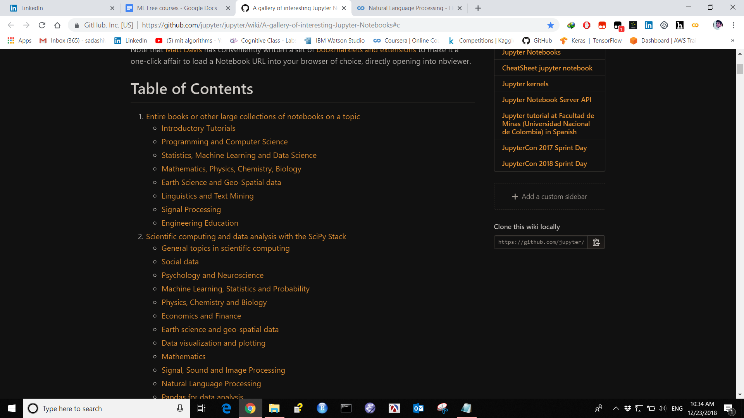

25. Some Useful Cheat Sheets

Pics of useful Cheat sheets containing Pandas numpy ML AI DS cheat sheets.

https://github.com/SadaShivPal/some-useful-cheat-sheets-in-ML-AI-Data-science

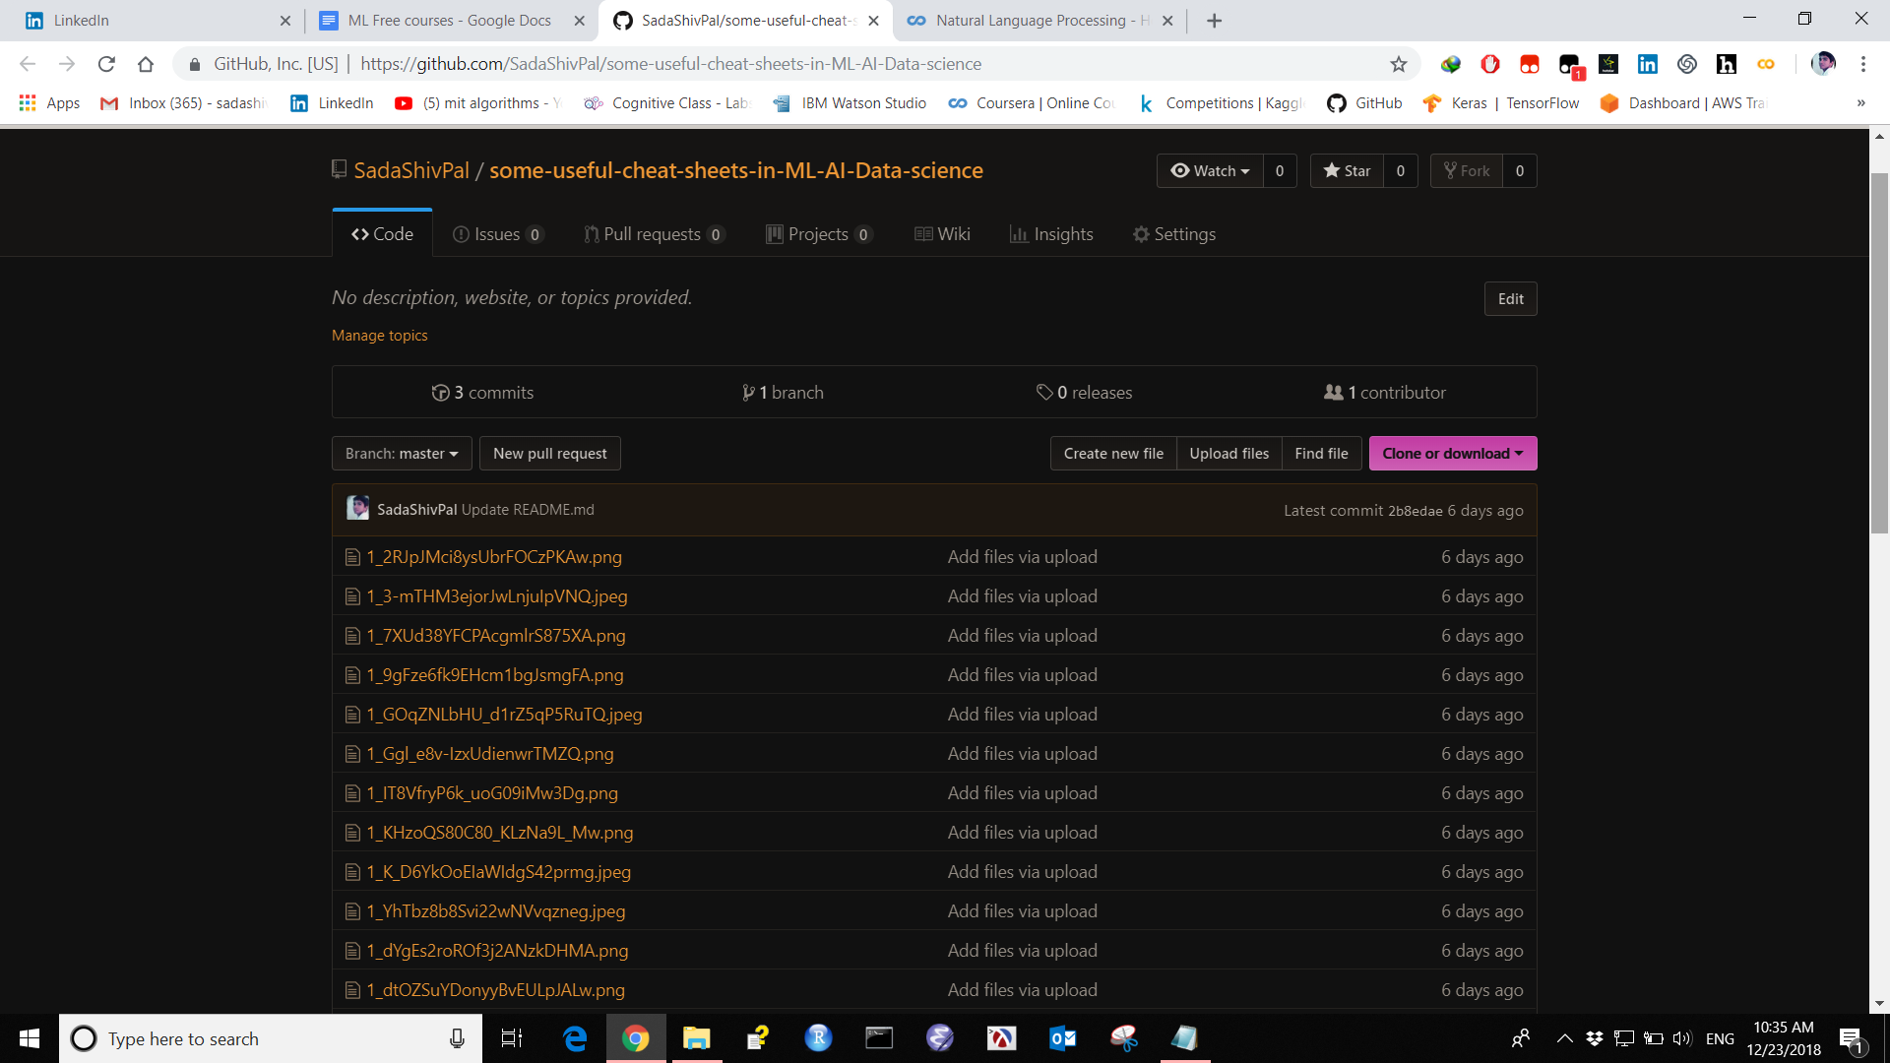jh

Deep Learning Lectures UC Berkeley
Register for Fall2018

https://inst.eecs.berkeley.edu/~cs188/fa18/

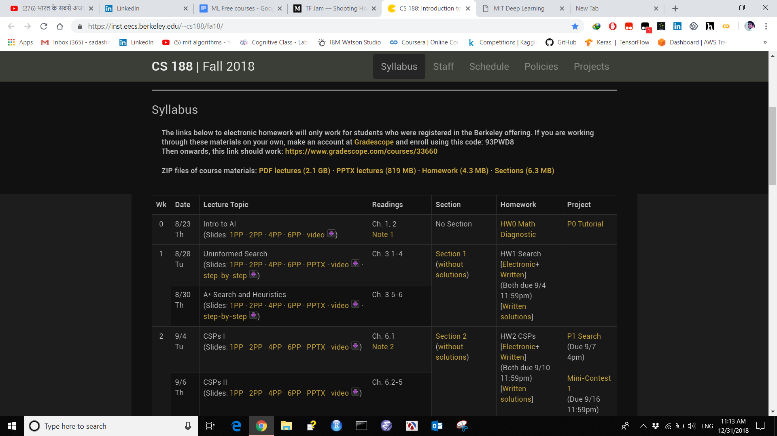

MIT Deep Learning

https://deeplearning.mit.edu/

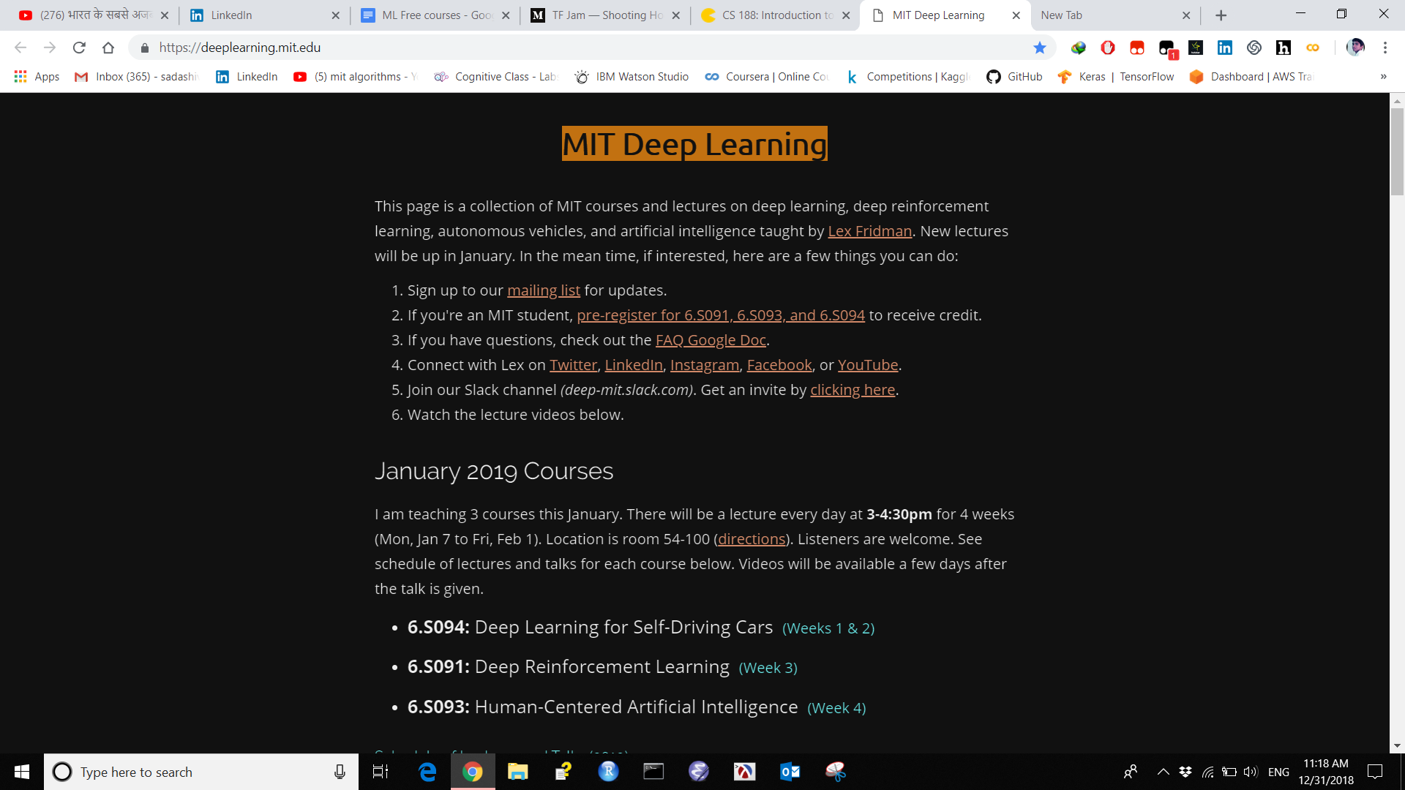

Open Source Society University

https://github.com/ossu/data-science

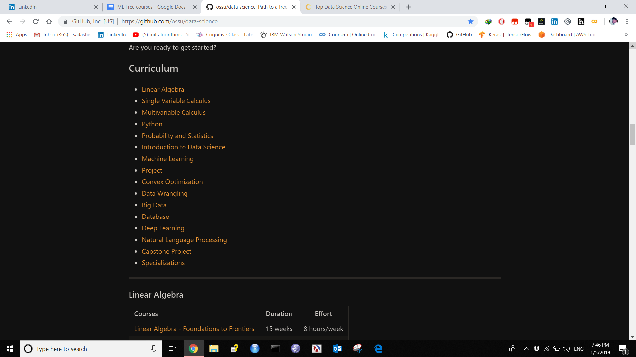

Top Data Science Online Courses in 2018

https://www.learndatasci.com/best-data-science-online-courses/

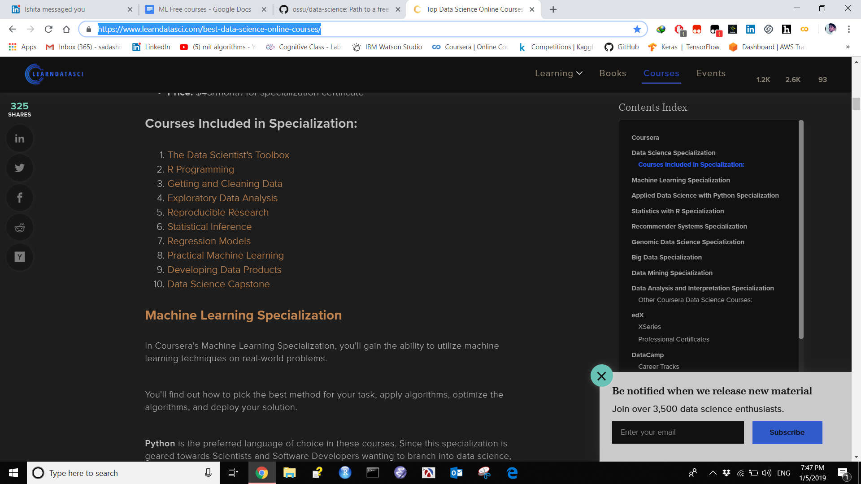

The best curated list of Data Science materials on the web!

http://www.claoudml.co/

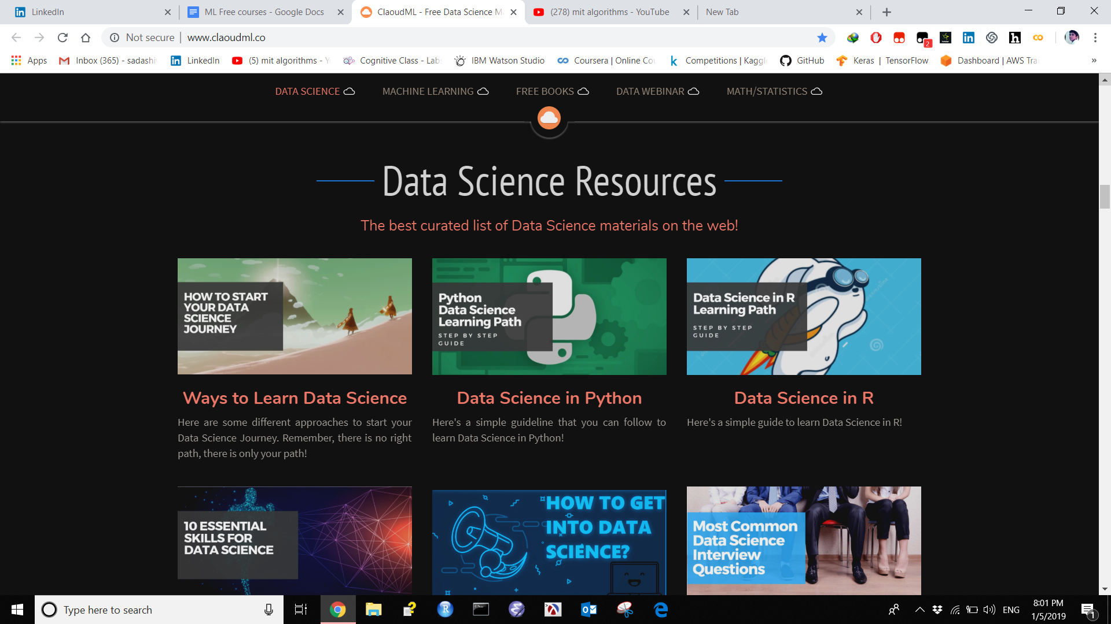

MIT Deep Learning

https://deeplearning.mit.edu/

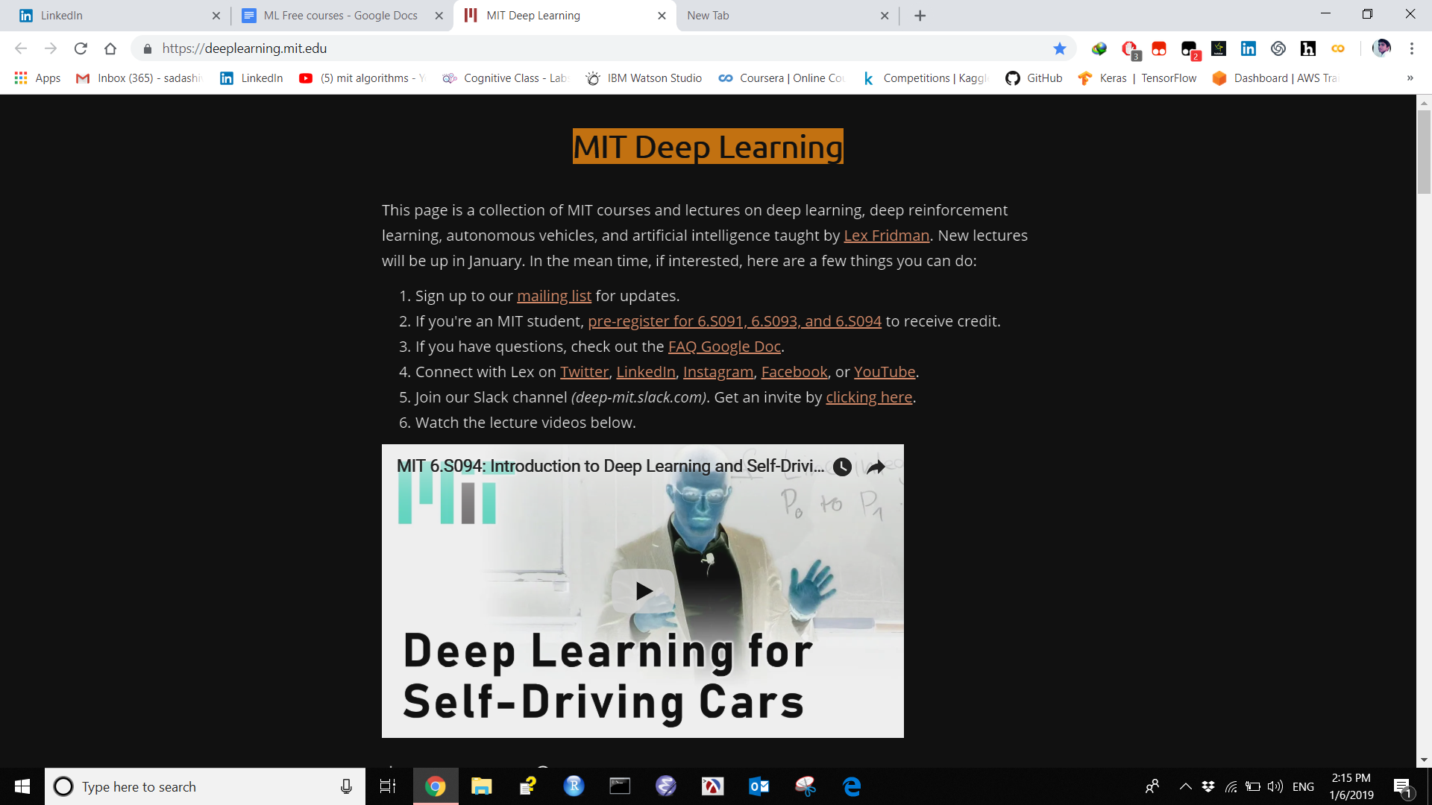

Deep Learning Summer School

http://videolectures.net/DLRLsummerschool2018_toronto/

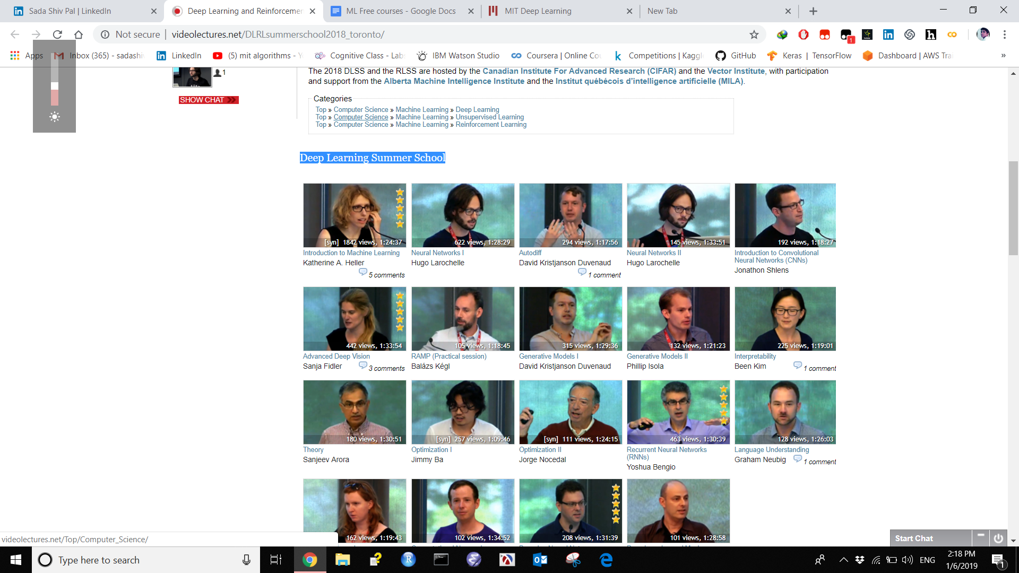

Data Science Flashcards

https://www.brainscape.com/subjects/data-science

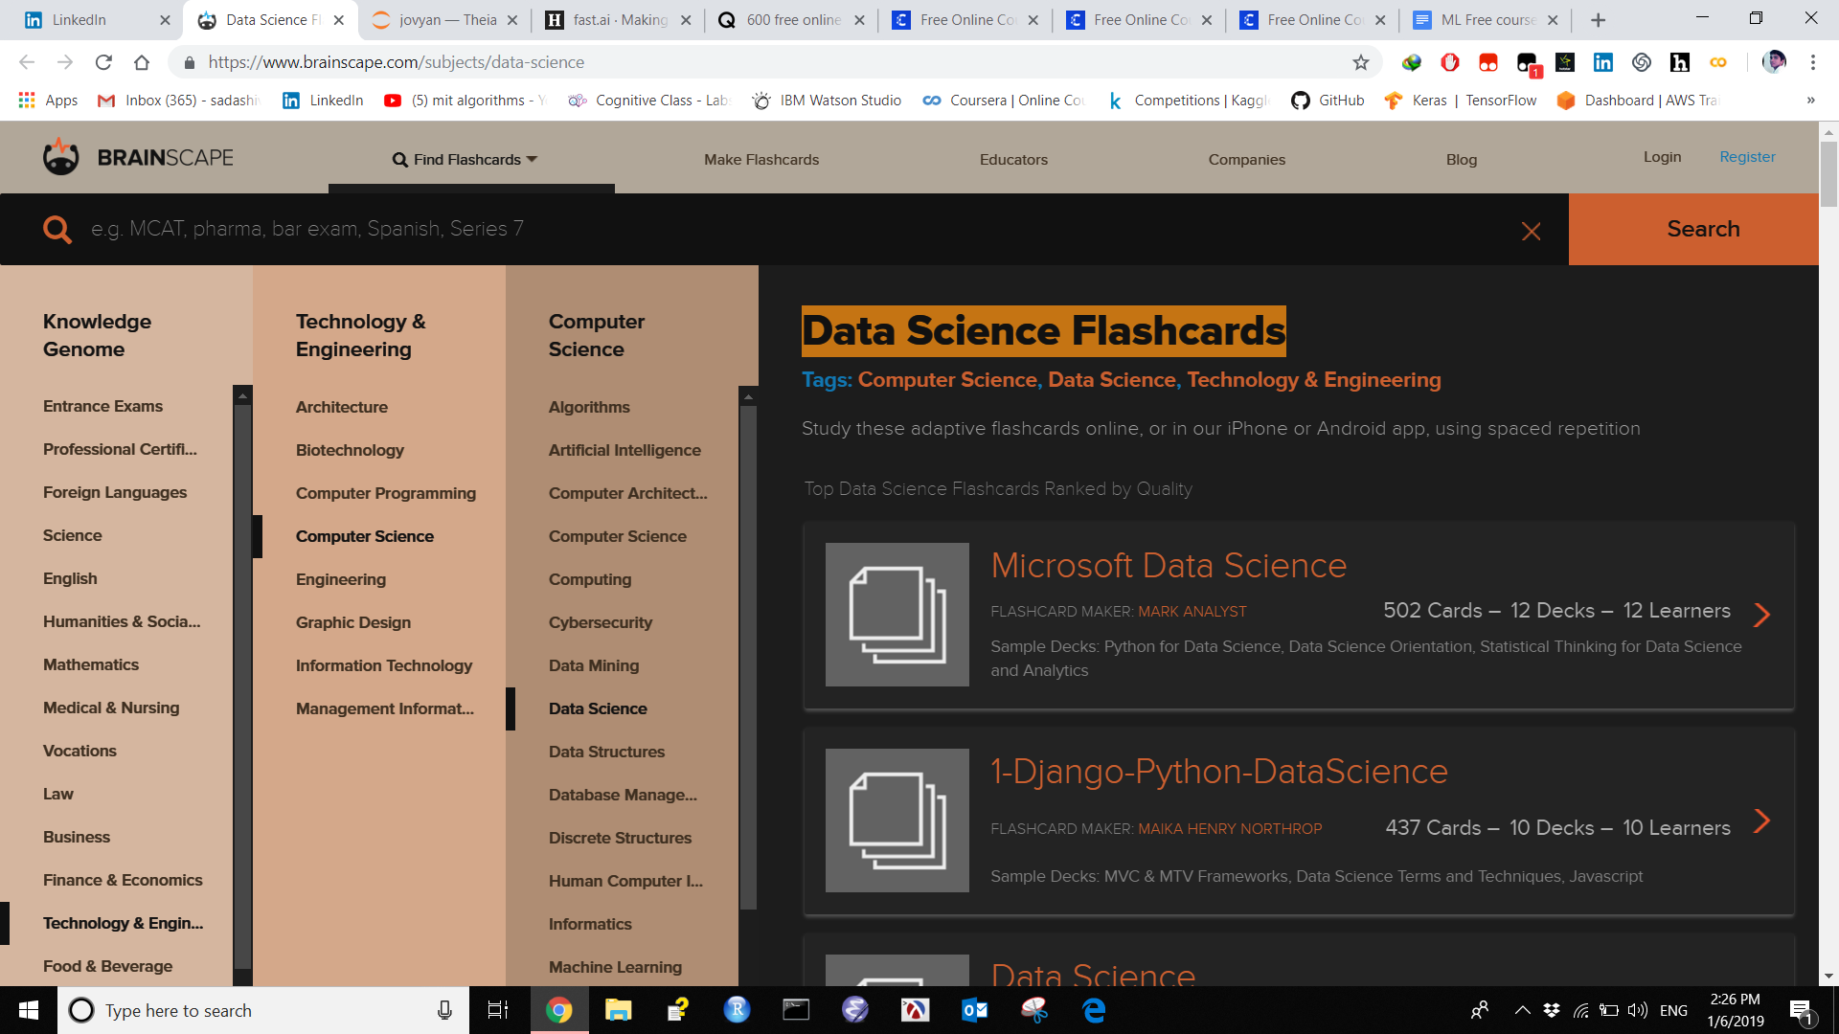

Fast.AI

https://www.fast.ai/

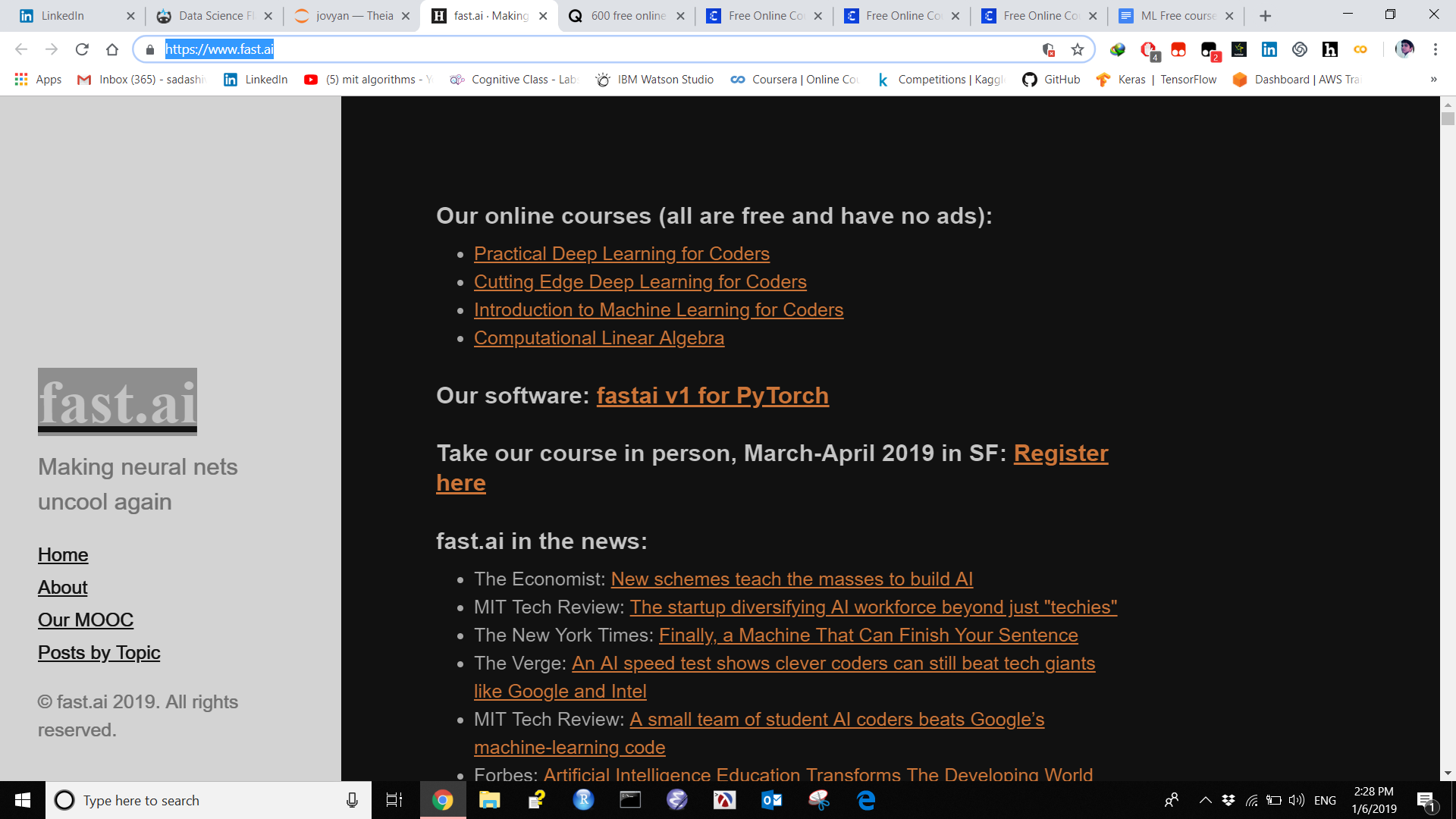

Fast.ai version-3

190 universities just launched 600 free online courses. Here’s the full list

https://qz.com/1437623/600-free-online-courses-you-can-take-from-universities-worldwide/

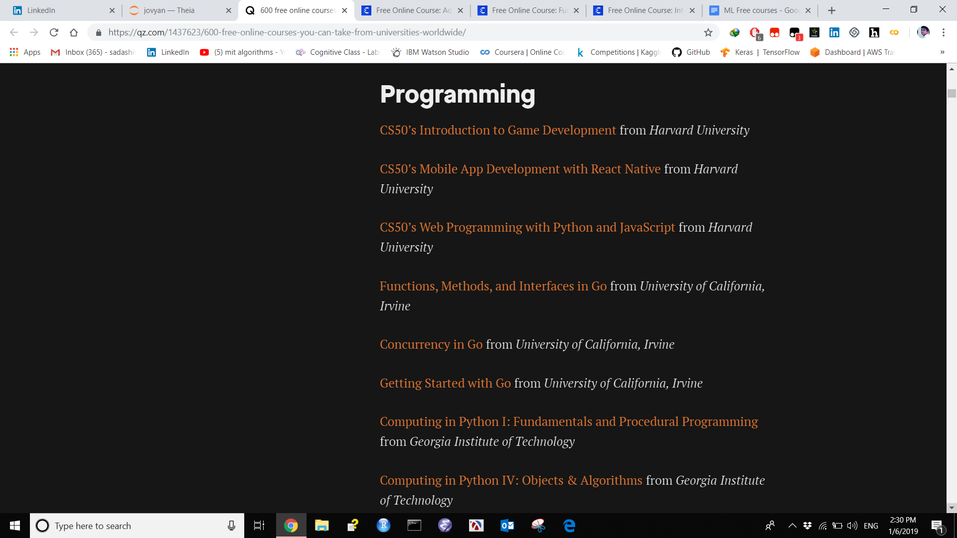

Advanced Algorithmics and Graph Theory with Python

https://www.class-central.com/course/edx-advanced-algorithmics-and-graph-theory-with-python-12017

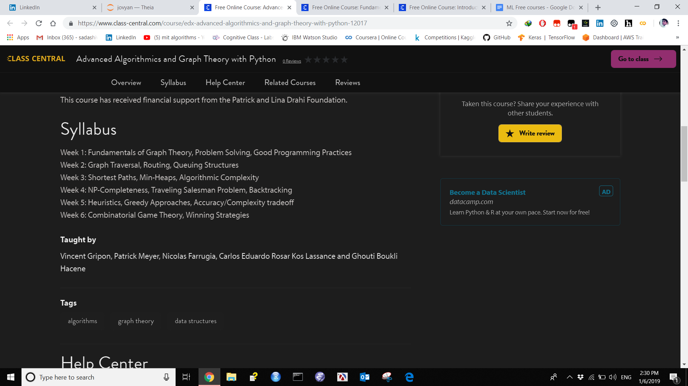

Fundamentals of Machine Learning

https://www.class-central.com/course/complexity-explorer-fundamentals-of-machine-learning-11493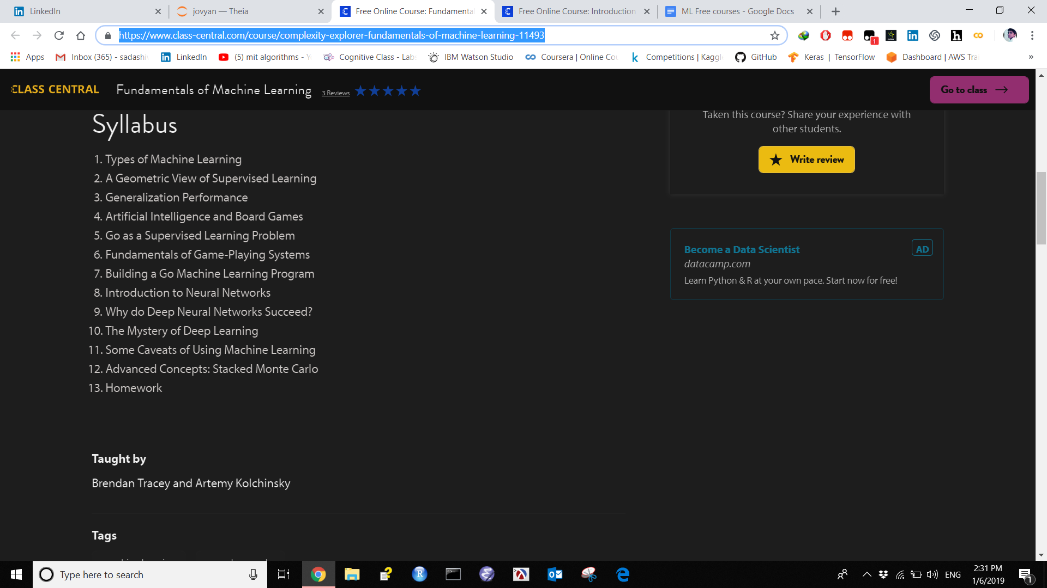

Introduction to Machine Learning

https://www.class-central.com/course/coursera-introduction-to-machine-learning-12086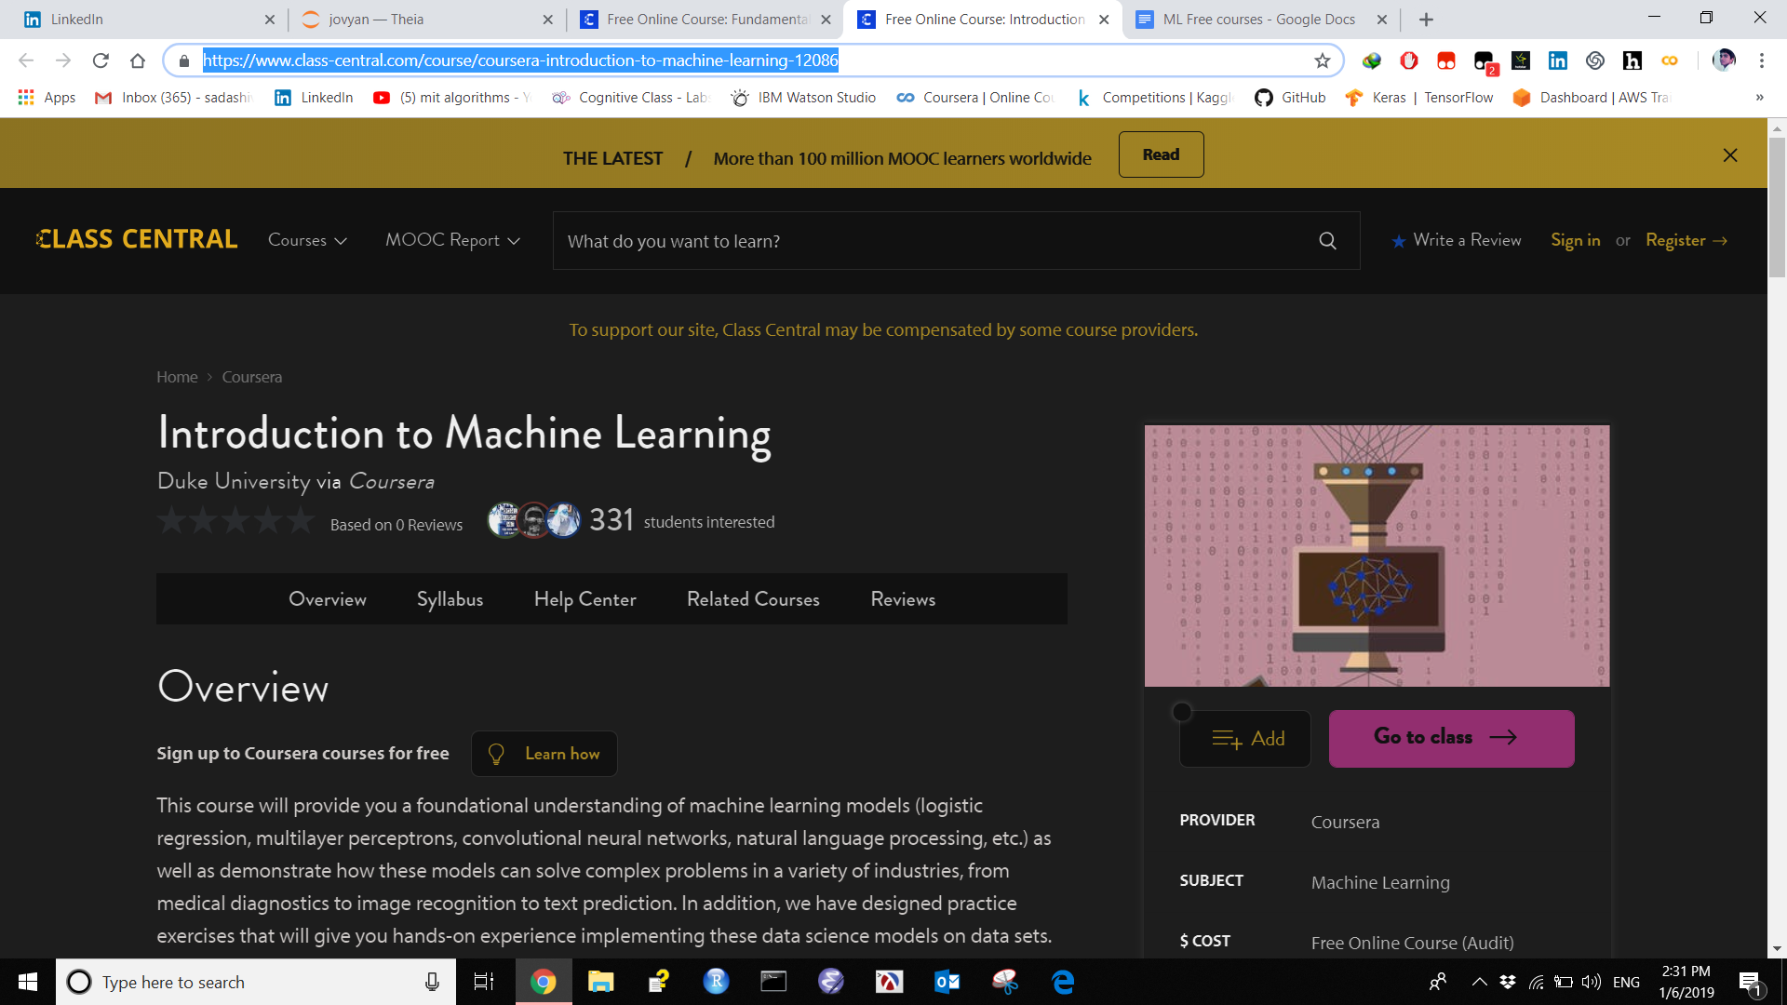

Topic Modeling

Vowpal wabbit
http://hunch.net/~vw/

State of Art Modeling
http://bigartm.org/

Gensim
https://radimrehurek.com/gensim/tutorial.html

Textvisualization

http://textvis.lnu.se/

